Roland Danielyan

Gender detection is interesting topic and can be tried to accomplish using tools used in our project. It’s clear we should expect that the estimation error wouldn’t be insignificant if we wouldn’t train or use machine learning models. But even using relatively simple tools we can get some results.

Firstly, it’s important to know what is the actual difference between faces of men and women, and what should we measure to guess whether a person is man or women. Apparently, we can’t use hair, as there are men with long hair and women with short hair, so we should find other observable differences.

According to some studies there are certain features in human faces that distinguish male faces from female ones.

In general, male noses are longer and wider, while female ones are shorter, narrower and more concave in profile. For that we can use results obtained in stage 2-1. 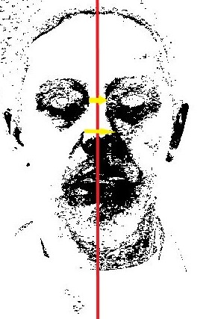Upper central part of picture by WIDTH/2, we can go down to a place where we assume the nose will start, then for each row we can move to the right and to the left, pixel by pixel until finding black pixel, then fix the distances, thus finding width of nose. Then we can get maximal and minimal width for upper and lower part of the nose and thus deciding persons gender according to some fixed thresholds.

Furthermore, male lips tend to be thinner, and the distance between the base of the nose and the top lip is larger for males than for females.

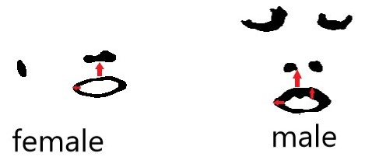So for that we can use results of 2nd layer binary regions with smothening techniques used in stage 1 of project. In the same fashion as in nose width estimations, we can measure distance between nose and upper lip. We can identify the lowest part of nose by desceding through the central height line of the picture (by identifying first black pixel, then when the black pixels end, and identifying the first white pixel,which would be the lowest point of nose). Then in the same fashion we would measure the distance between lowest pixel of nose, and upper pixel of lip, which then we would compare to decide gender.